Living Hope Lutheran Church
The Heart of Christ in the Heart of the City

Third Sunday after Epiphany
January 29, 2023 9:00am

PRELUDE I Will Praise You Lord Claude Fravsse
WELCOME Pr. Matt Metevelis

CALL TO WORSHIP
P The grace of our Lord Jesus Christ, the love of God, and the communion of the Holy Spirit be with you all.
C And also with you.

OPENING HYMN Love Divine All Loves Excelling Hymn #631

CONFESSION & FORGIVENESS
P Blessed be the holy Trinity, ☩ one God, who stretches out the heavens, who is eager to forgive and who loves us beyond our days.
C Amen.

P Dear friends, together let us acknowledge our failure to love this world as Jesus does

Silence is kept for reflection.

P God of mercy and forgiveness,

C We confess that sin still has a hold on us. We have harmed your good creation. We have failed to do justice, love kindness, and walk humbly with you. Turn us in a new direction. Show us the path that leads to life. Be our refuge and strength on the journey, through Jesus Christ, our redeemer and friend. Amen

P Beloved of God: Your sins are forgiven ☩ and you are made whole. God points the way to new life in Christ, who meets us on the road. Journey now in God’s abiding love through the power of the Holy Spirit.

C Amen.

APOSTLES CREED

I believe in God the Father almighty, creator of heaven and earth

I believe in Jesus Christ, God’s only Son, our Lord, who was conceived by the Holy Spirit,
born of the Virgin Mary, suffered under Pontius Pilate,
was crucified, died and was buried;
he descended into hell.
On the third day he rose again; he ascended into heaven,
he is seated at the right hand of the Father,
and he will come to judge the living and the dead.

I believe in the Holy Spirit, the holy Catholic church,
the communion of saints, the forgiveness of sins,
the resurrection of the body, and the life everlasting.

Amen

PRAYER OF THE DAY

P O God of abundance,
C You bless us those who are poor in spirit, grieving, oppressed, and humble. Help us to strive for peace and righteousness with your Son Jesus who bears all things with us.

CHILDREN’S MESSAGE

SPECIAL MUSIC Spirit of God Hanneke Jacobs

GOSPEL ACCLAMATION (Psalm 111, et. al.)

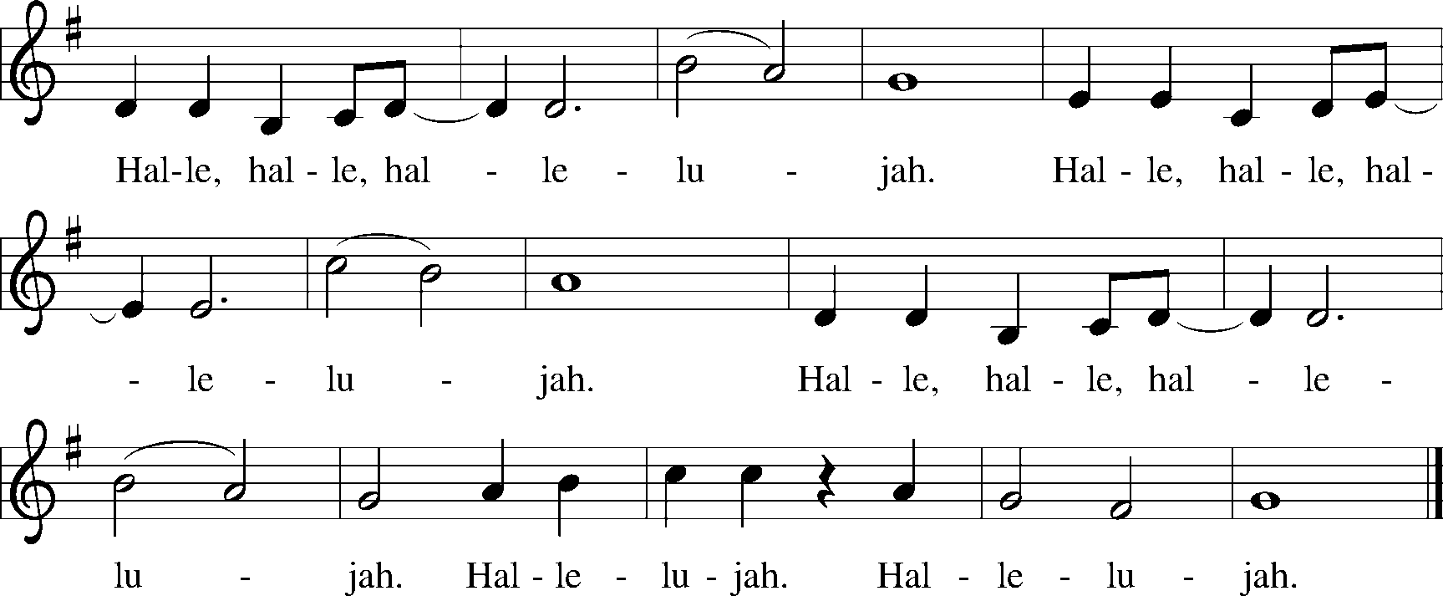

THE GOSPEL
P The Holy Gospel according to Matthew 5:1-12
C Glory to you, O Lord.

P When Jesus saw the crowds, he went up the mountain, and after he sat down, his disciples came to him. And he began to speak and taught them, saying:

“Blessed are the poor in spirit, for theirs is the kingdom of heaven.

“Blessed are those who mourn, for they will be comforted.

“Blessed are the meek, for they will inherit the earth.

“Blessed are those who hunger and thirst for righteousness, for they will be filled.

“Blessed are the merciful, for they will receive mercy.

“Blessed are the pure in heart, for they will see God.

“Blessed are the peacemakers, for they will be called children of God.

“Blessed are those who are persecuted for the sake of righteousness, for theirs is the kingdom of heaven.

“Blessed are you when people revile you and persecute you and utter all kinds of evil against you falsely on my account. Rejoice and be glad, for your reward is great in heaven, for in the same way they persecuted the prophets who were before you.

P The Gospel of the Lord.
C Praise to you, O Christ.
SERMON

OFFERING

All that we have belongs to God, and we give faithfully in gratitude for God’s abundance, as a practice of discipleship, and to serve the needs of those around us. Our mission to bless and serve our neighbors matters now more than ever.

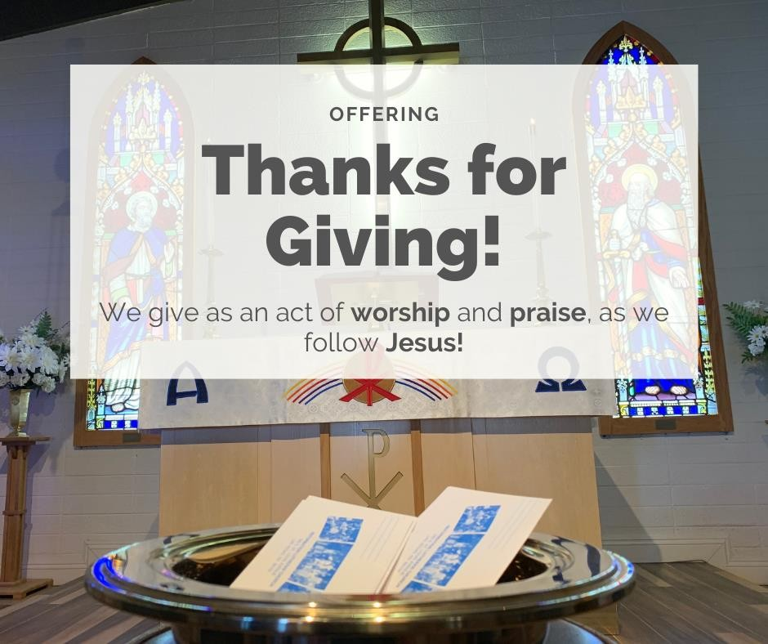
You can give your offering online to our church
at www.livinghopelasvegas.org

Using the Vanco Mobile (simply giving) on your smart phone:
- Download the free mobile app from the App Store or Google Play by searching for “Vanco Mobile.”
- Locate our church by ZIP code
(89104) or name.
- Donate!
or by mail to:
Living Hope
580 E. Saint Louis Ave. Las Vegas, NV 89104
Thank you for your generosity!
For more info on giving to Living Hope, look for the Giving Brochure in the Narthex or talk to Mary La Barbara, office manager.

OFFERTORY How Beautiful The Hands that Served Twila Paris

PRAYERS OF THE PEOPLE

THE GREAT THANKSGIVING

P The Lord be with you.
C And also with you.

P Lift up your hearts.
C We lift them to the Lord.

P Let us give thanks to the Lord our God.
C It is right to give our thanks and praise.

P It is indeed right, our duty and our joy, that we should at all times and in all places give thanks and praise … we praise your name and join their unending hymn:
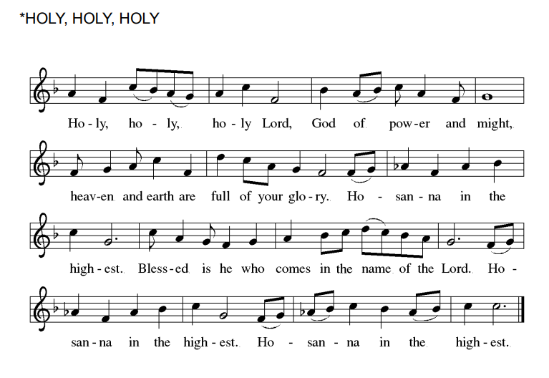

WORDS OF INSTITUTION (1 Cor. 11:23-25)
P In the night in which he was betrayed…

LORD'S PRAYER
Our Father in heaven, hallowed be your name, your kingdom come, your will be done,
on earth as in heaven.
Give us today our daily bread.
Forgive us our sins as we forgive those who sin against us.
Save us from the time of trial and deliver us from evil.
For the kingdom, the power, and the glory are yours, now and forever. Amen.

DISTRIBUTION OF ELEMENTS

P We who are many are one body, for we all partake of the one bread. Come. Be filled with light and life.

You may come forward as directed by the ushers, receive bread, and take a cup with either wine (in the round tray) or white grape juice (in the rectangular tray) and return to your seat.

PRAYER AFTER COMMUNION

P Let us pray. Life giving God,
C Through this meal you have bandaged our wounds and fed us with your mercy. Now send us forth to live for others, both friend and stranger, that all may come to know your love. This we pray in the name of Jesus. Amen.

ANNOUNCEMENTS

BLESSING

P The Lord bless you and keep you the Lord’s face shine on you with grace and mercy. The Lord look upon you with favor and give you peace.
C Amen.

SENDING HYMN To Be Your Presence Hymn #546

SENDING
P Go in peace.
C Sharing the heart of Christ in the Heart of the City! Thanks be to God!

POSTLUDE It Is Well With My Soul Phillip Paul Bliss

Preaching today: Tia Heinreich
Worship: Pr. Matt Metevelis
Music: Barbara Siegel
Greeter: Sarah Filer
Communion Assistants: Elaine Hansen, Jan Ibrahim, &
Penny Hovick
Usher: Sarah Filer
Next Sunday:
February 5

Augsburg Fortress SAS000729; OneLicense A-731615, CCLI 11262137

Living Hope Lutheran Church is a Reconciling in Christ congregation of the Evangelical Lutheran Church in America. www.reconcilingworks.org

Last Week’s Worship Attendance:
In person: 31
Online Streaming Views: 44

PRAYERS
Please remember in prayer: Dr. Mark Wickstrom, Suzanne Cason, Han Stover, Braydin, Vinny, Tammy’s sister Terry, Lois Keeton, Christy Lyn Gamber and her father Eldon, Taylor, Debby and Kelly Dailey, Helen Smith’s husband Bruce, Donna Delancy Spierer, The Windes Family, Sara Siller, Stephen Sappington, Pete Geloff, Pat Ward, Jeremy Filer, refugees and all affected by the war in Ukraine.

🙏

Youth News

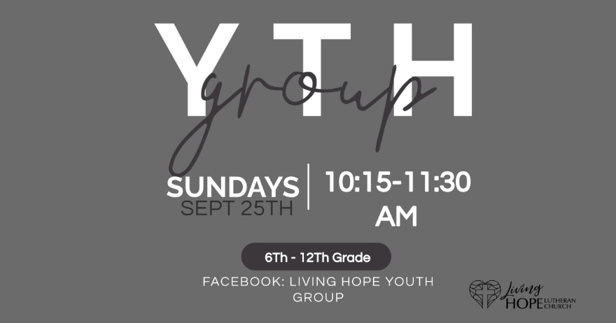

Living Hope Singers

Come share your musical talents with Living Hope! Please contact Dr. Le to sign up to join the Living Hope Singers or email her at music@livinghopelasvegas.org.
Sing your praises unto the Lord.

Help Wanted

We are looking for a few good people!
Do you like to read?
Do you like to pray?
Do you like to serve people food and beverage?
Please sign up for various worship assistant positions
with Mary or Sarah Filer.
Thank you!

Reminder
Semi Annual Church meeting will be held TODAY.
The meeting will be in Edwins Hall at 10:15 am and will include a continental breakfast. There will be no adult bible study that day.
All members are encouraged to attend.

NEVADANS FOR THE COMMON GOOD
The Nevada legislative session begins on Monday, Feb. 6th. NCG will offer the second of a two-part training series for those interested in understanding how the session works and how to make public comment on bills. Save the date --
- Wednesday, February 15th at 6:30 pm, at Green Valley United Methodist Church: “Understanding Public Comment, Leadership, and How to Follow the Session”
Please contact Paul Hansen for sign up details at 702-335-3735.

